S. No. | Section Title
1 | Title of the Project
2 | Code and Explanation
2.1 | Overview
2.2 | backup.sh Script and Explanation
2.3 | update.sh Script and Explanation
2.4 | monitor.sh Script and Explanation
2.5 | menu.sh Script and Explanation
3 | User Manual
3.1 | Setup and Permissions
3.2 | Running the Suite
3.3 | Important Notes
4 | Output / Screenshot Section
4.1 | Menu Running in Terminal
4.2 | Backup Script Output
4.3 | Update Script Output
4.4 | Monitor Script Output
4.5 | Backup Directory Contents

Title

Bash Scripting Suite for Automated Linux System Maintenance

SUBMITTED BY – SWAYAM KUMAR GOUDA
REGD.NO – 2241007041
SECTION – 2241007
BRANCH – C.S.E(DATA SCIENCE)
BATCH.NO – 001

2. Code and Explanation
2.1 Overview
This project provides a suite of Bash scripts designed to automate essential Linux system maintenance tasks.
The key functionalities include:
- Automated backup of important files and directories.
- System update and cleanup using package management commands.
- Log monitoring to keep track of system events.
- An interactive script menu to run these maintenance tasks easily.
These scripts help users (especially system administrators) maintain their systems efficiently, reduce manual effort, and prevent data loss through regular automated backups.

2.2 backup.sh Script and Explanation
CODE:
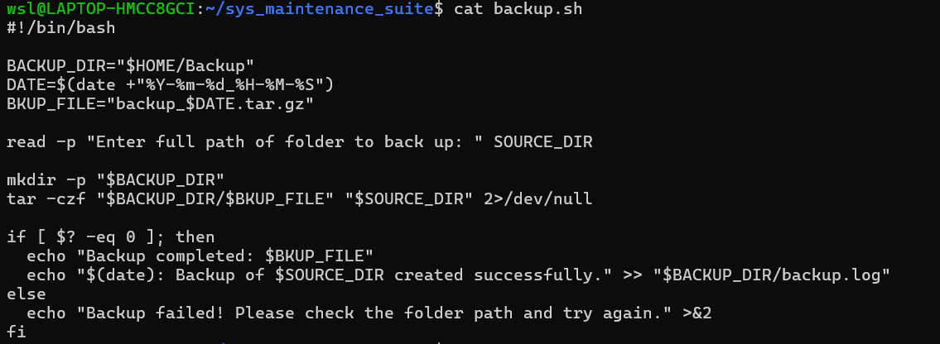

Explanation
This script automates the creation of backups for the user’s Documents directory.
- It first checks for a Backup folder inside the user’s home directory and creates it if missing.
- It then compresses (tar -czf) the Documents directory into a timestamped archive.
- The script verifies whether the backup was successful using the exit status $? and provides user feedback.
This ensures that backups are taken regularly and stored with unique timestamps.

2.3 update.sh Script and Explanation
CODE:
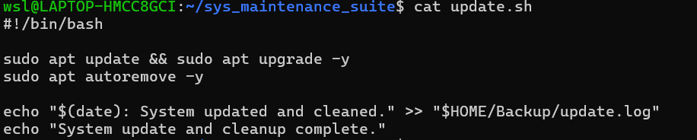
Explanation
This script automates system updates and cleanups on Ubuntu/Linux-based systems.
- It performs package updates (apt update) and upgrades all available packages (apt upgrade -y).
- Unused packages are removed automatically (apt autoremove -y).
- The entire process is logged with a timestamp inside the ~/Backup/update.log file.
- This helps maintain system integrity and keeps the system free .

2.4 monitor.sh Script and Explanation
CODE:
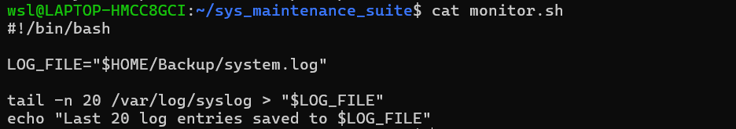
Explanation
This script assists in monitoring system logs by:
- Fetching the last 20 lines of /var/log/syslog.
- Saving the output in ~/Backup/system.log.
It allows the user to quickly review recent system activity and detect issues without navigating through large log files.

2.5 menu.sh Script and Explanation
CODE:
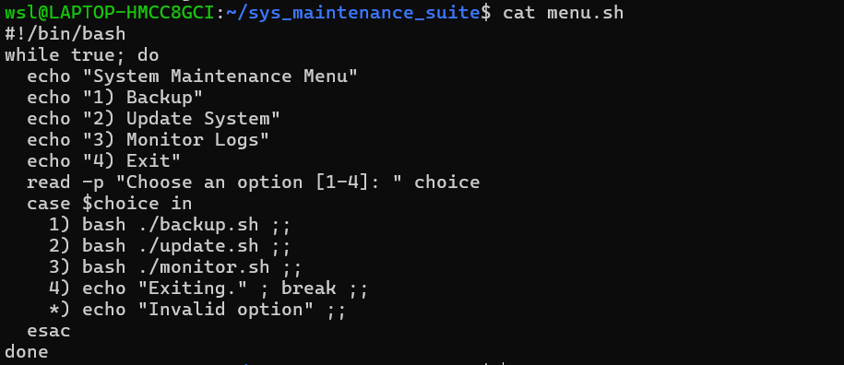

Explanation
This script acts as the interactive interface for users.
- It presents a simple menu-driven system where users can select operations by entering a number (1–4).
- Each option runs the corresponding script for backup, update, or monitoring.
- The loop continues until the user chooses to exit.
This design enhances usability, especially for beginners or system administrators managing multiple systems.

3. User Manual
3.1 Setup and Permissions
1. Create a folder to store the project
Command : mkdir sys_maintenance_suite
cd sys_maintenance_suite
2. Save all four scripts — backup.sh, update.sh, monitor.sh, and menu.sh — inside this folder.
3. Give execution permissions to all scripts:
Command: chmod +x backup.sh update.sh monitor.sh menu.sh

3.2 Running the Suite
1. Start the interactive maintenance suite by running:
Command : ./menu.sh
2. The menu will appear as:
System Maintenance Menu
1) Backup
2) Update System
3) Monitor Logs
4) Exit

3. Choose the desired option:
- Enter 1 → Runs backup.sh to back up your Documents folder.
- Enter 2 → Runs update.sh to update and clean your system.
- Enter 3 → Runs monitor.sh to view recent system logs.
- Enter 4 → Exits the suite.

4. Screenshot Section(OutPut)

4.1 Menu Running in Terminal
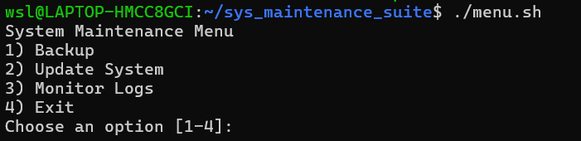

4.2 Backup Script Output
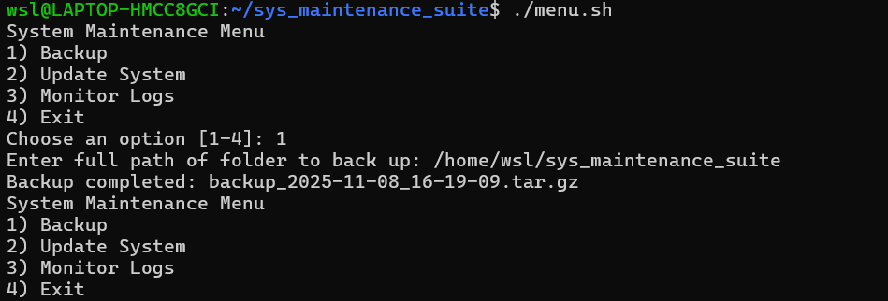

4.3 Update Script Output
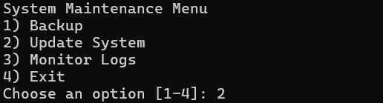

4.4 Monitor Script Output
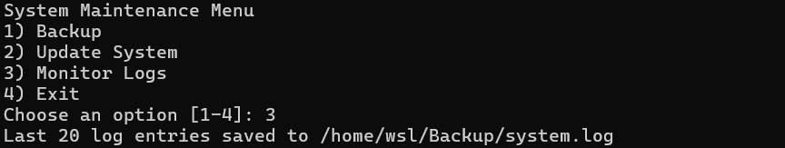

4.5 Overall Output

4.6 Exit
